**Memo**

To: Professor Pisano

From: Yuri Zhang, Bailey Brake, Ruohui Huang, Emily Lampat, Khang Le

Team: 9

Date: 11/19/2023

Subject: 1st Prototype Test Report

# Test Setup

## Bill of Materials:

**Hardware**:

* LED Light: Selected for its efficiency and brightness, which are crucial for our application.
* Arduino Trinket Microcontroller: Chosen for its compact size and lack of unnecessary functions, making it ideal for our streamlined prototype.
* Oscilloscope: Essential for accurately measuring the LED's flicker frequency and ensuring our product meets the required specifications.
* Probes/Wires: For connecting and testing the circuit.
* Resistors: Calculated to match the LED's specifications, ensuring optimal current flow without risking damage.
* Laptop Computer: Used for programming the Arduino and monitoring the test.
* Tactile Push Buttons: For manual control over the LED's brightness levels.

**Software**:

* Arduino IDE
  + Arduino script to generate 40Hz light frequency.
  + Take buttons as input to write into LED output, adjusting its brightness.

## Setup Procedure:

Our setup has been carefully designed to replicate a natural application environment.

The Arduino Trinket is the central control unit connected to the laptop via a USB connection. This setup is essential for programming the microcontroller and allows real-time monitoring and adjustments during testing. An oscilloscope is used to continuously monitor the electrical characteristics of the LEDs, including flicker frequency and brightness levels. Two probes from an oscilloscope were connected to the LED to measure the output frequency, given the difficulty of observing the 40Hz flicker rate with the naked eye.

The setup process involves careful calibration of the device. The LEDs are connected to the Arduino Trinket through a series of resistors and wires, ensuring that the current flowing through the LEDs is within safe limits. Tactile buttons are integrated into the circuitry to adjust the brightness of the LEDs manually. This setup aspect is essential because it simulates the end user's interaction with the product.

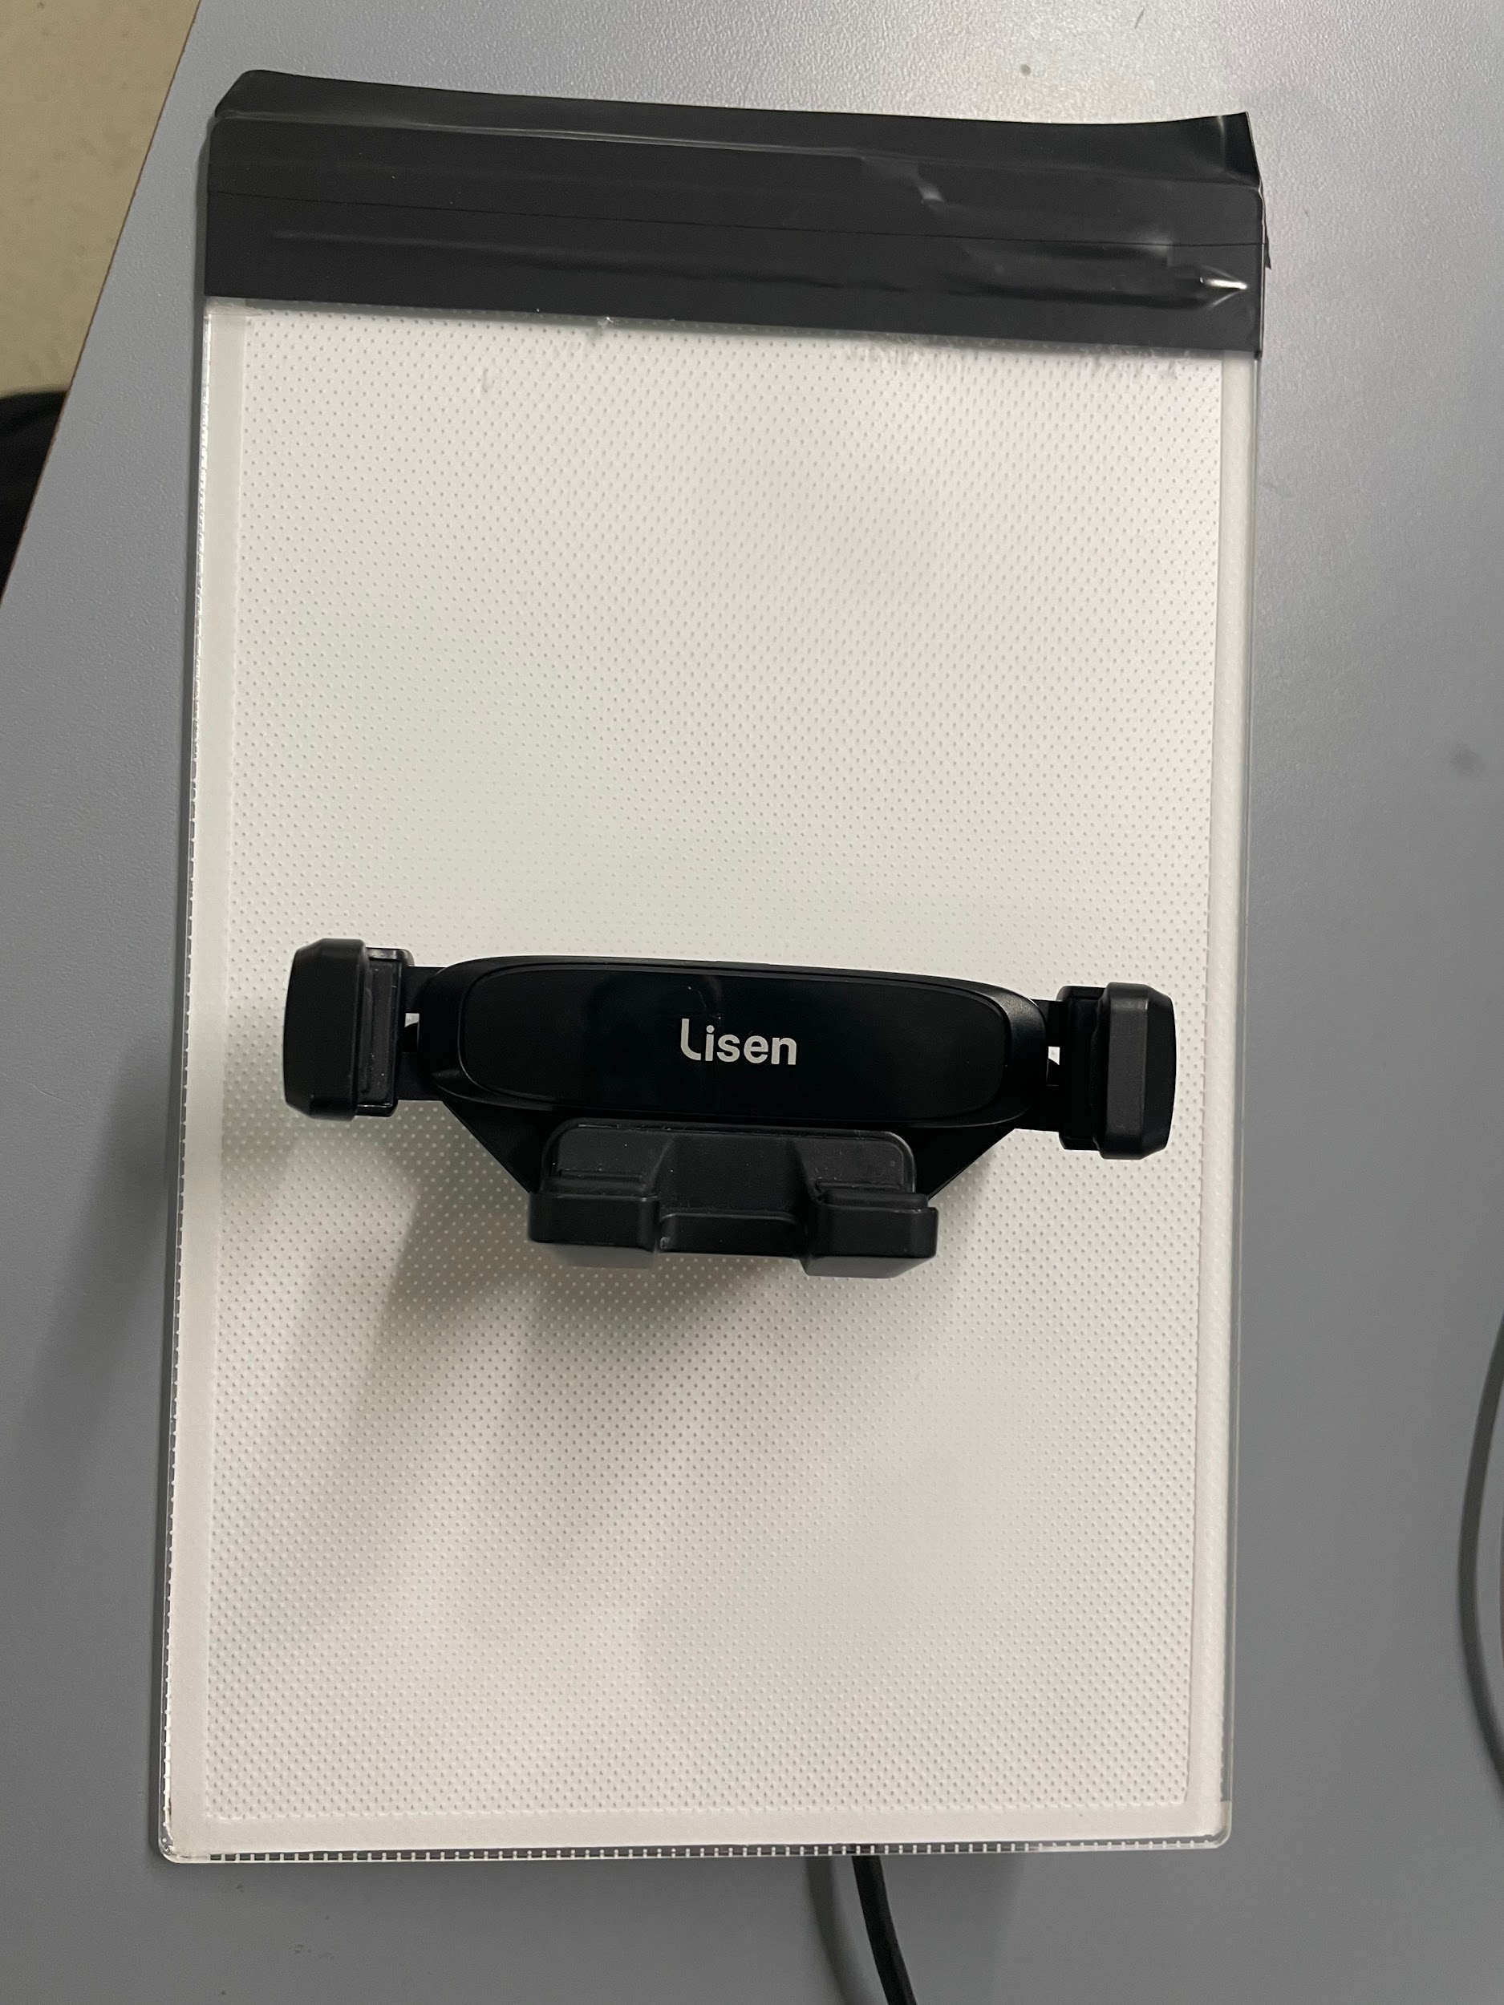

Figure 1. Front of LED Panel T0 Model

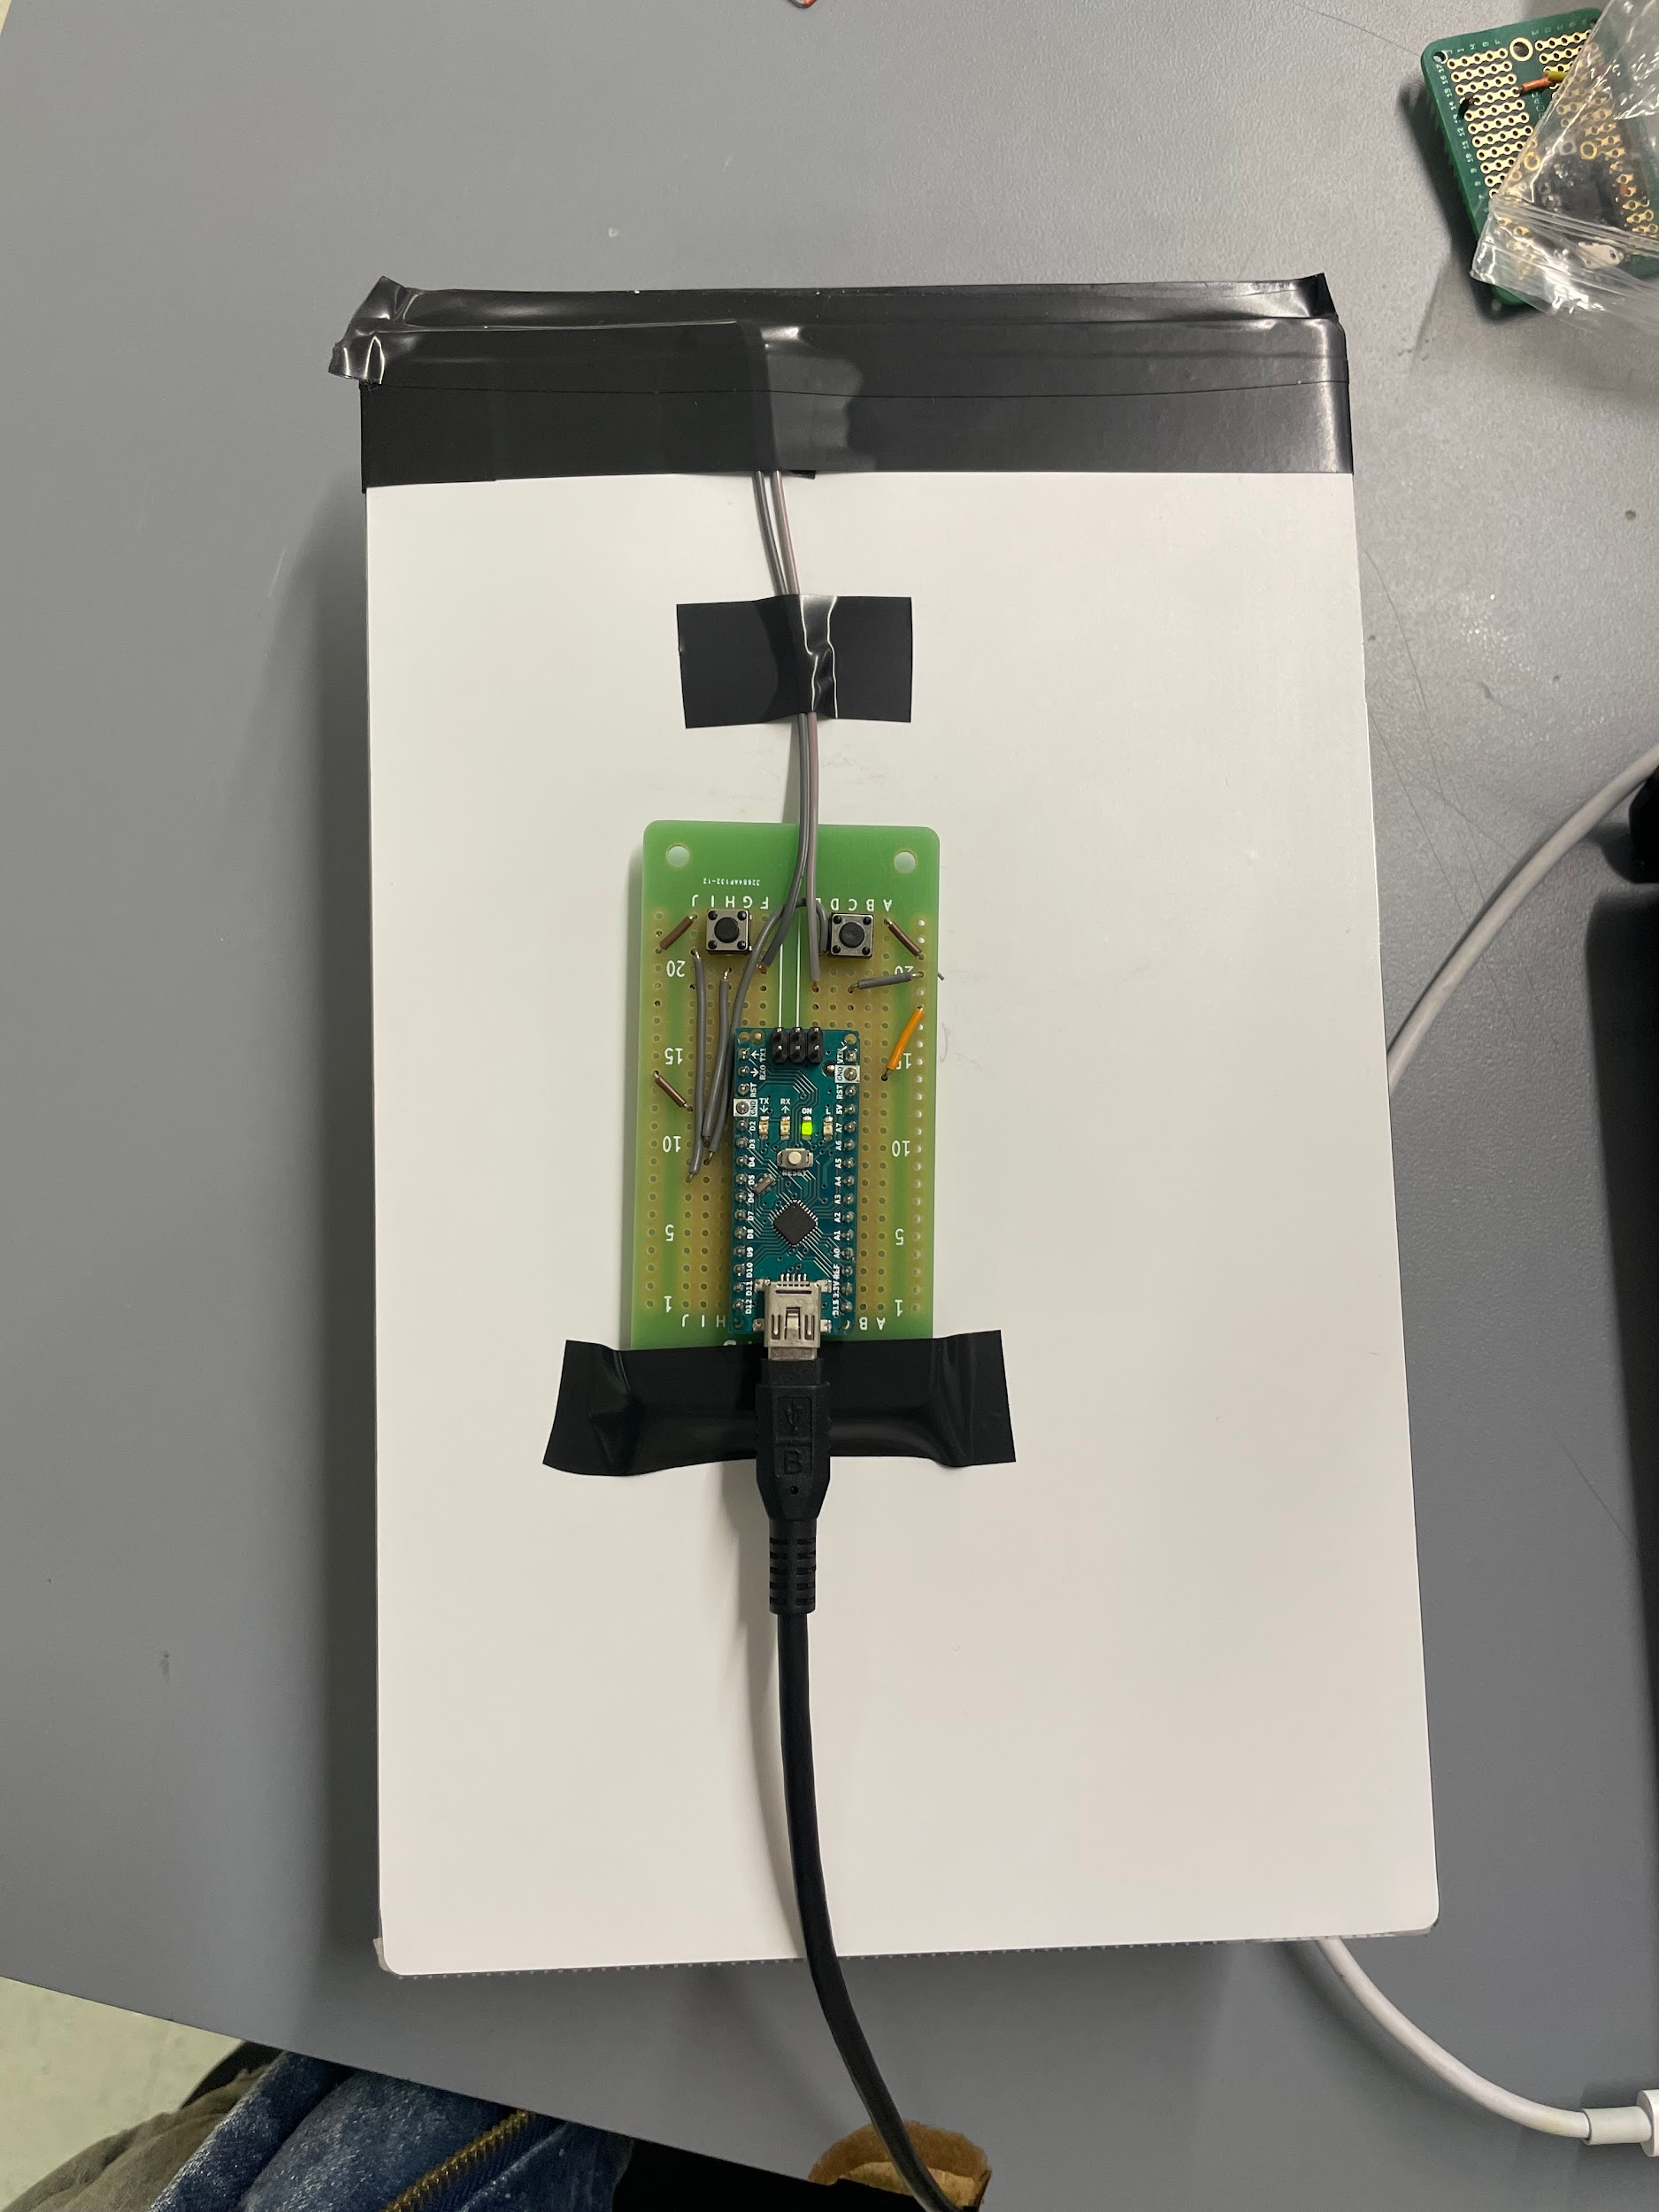

Figure 2. Back of LED Panel T0 Model

*Figure 1: Illustration of Circuit Setup*

# Results and Measurements

## Flicker Frequency Measurement:

In order to measure the flicker frequency, we set a time interval of 25ms on the oscilloscope, which is the desired time period of a flicker, considering we want 40Hz and t = 1/f = 1/40Hz = 0.025s. The LED's on-off cycle was observed to be consistent within this timeframe, with a deviation of less than 0.5ms, indicating high precision in frequency control.

## Brightness Adjustment Measurement:

As for the brightness adjustments, we had two buttons separately increasing/decreasing the brightness. During our testing, as we pressed and held each button, the brightness gradually increased/accordingly reduced to the controller. Once it reached a maximum of brightness/dimness, it stayed there. We could turn it back on by pressing and holding the button.

The brightness control was tested over a range of 0 to 255 in 10 increments. Each button press resulted in a smooth transition between brightness levels, with the oscilloscope showing a corresponding change in voltage across the LED. The maximum and minimum brightness levels were consistent across multiple tests, demonstrating the reliability of our control mechanism.

# Conclusion and In-Depth Analysis

## 3.1 Conclusion:

The prototype test successfully demonstrated the core functionalities of our design. The Arduino script effectively maintained a 40Hz flicker frequency, which is crucial for our application's requirements. The manual brightness adjustments were responsive and precise, indicating a well-designed user interface.

## 3.2 Future Directions:

Our next steps involve transitioning to the Trinket M0 microcontroller for a more compact and efficient design. We will also integrate LED strips per our client's request and proceed with soldering to ensure robust and reliable connections. Further, we plan to conduct extensive user testing to refine the interface and ergonomics of our product.

## 3.3 Reflective Analysis:

The test setup and results aligned with our initial test plan, validating our equipment choices and design approach. The precision in flicker frequency control and the effective brightness adjustment mechanism were crucial achievements. In subsequent iterations, we will continue refining our design, enhancing circuit efficiency and user experience.

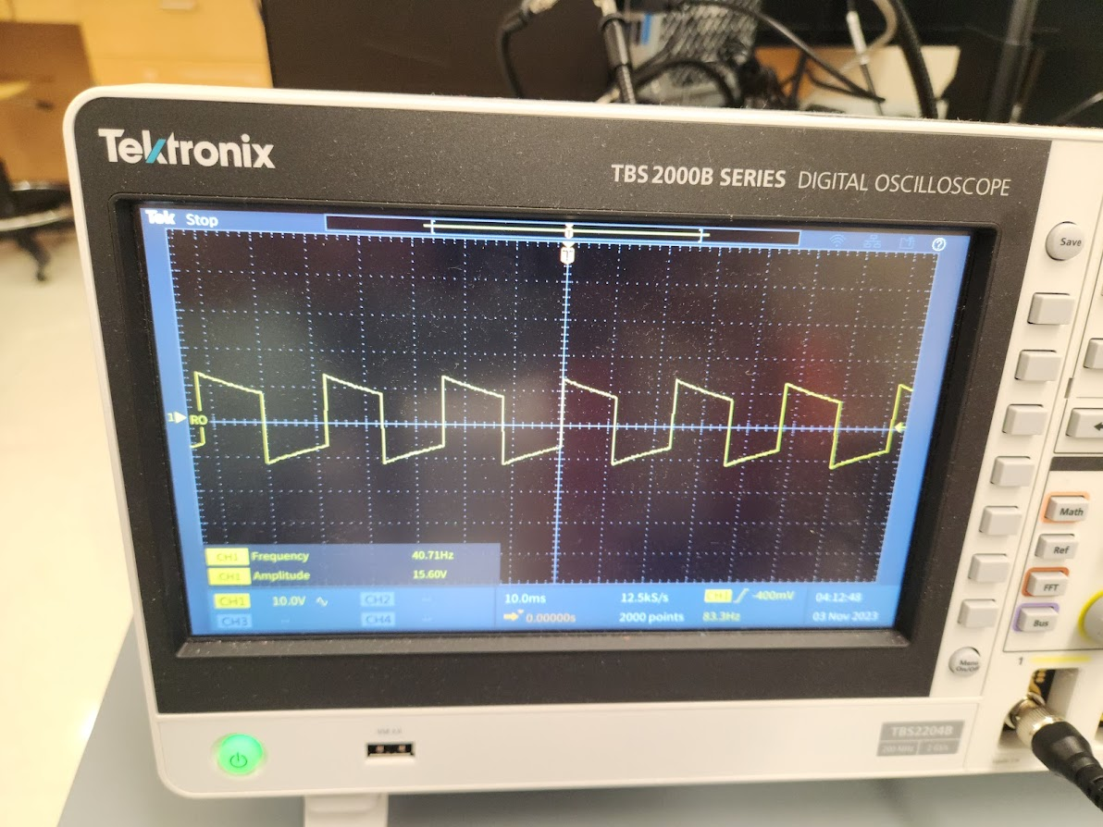 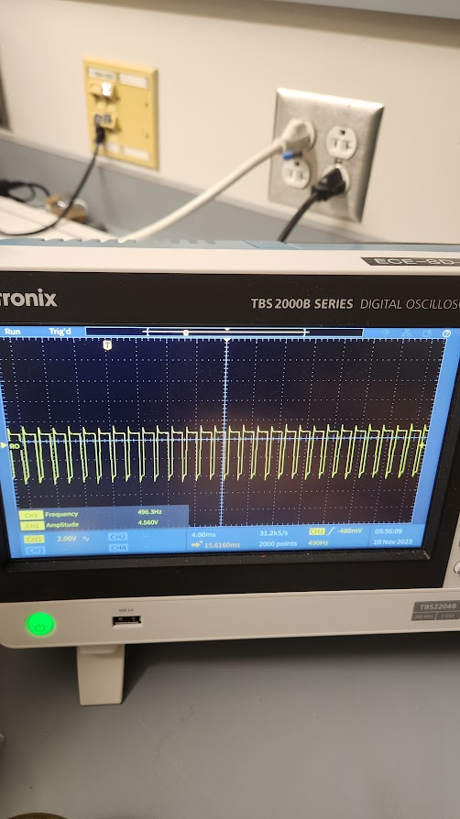

*Figure 2: Waveform showing 40Hz capability* *Figure 3: Zoomed-in wave to show PWM*



*Figure 4: Simplified PWM representation with varying brightnesses*